Subject: Save Money & Go Green with Xerox Compatible Toner Cartridges!

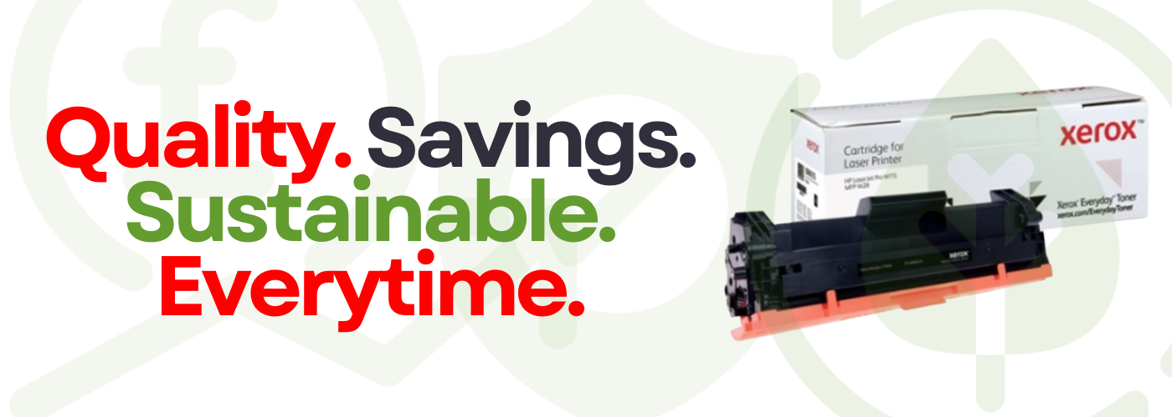
Dear [Customer Name],
Here at (Insert Company name) , we’re excited to offer a fantastic range of Xerox-branded Compatible Toner Cartridges, available for delivery in for all of our customers. Our cartridges work with popular printer brands like Brother, HP, Kyocera, Lexmark, and Samsung.
Why Choose Xerox Compatible Toners?
- Save 50-60% compared to original cartridges
- Reliable Performance – vibrant colours and crisp text on every page
- Eco-Friendly Packaging – 100% plastic-free and recyclable
- Lifetime Guarantee – free replacement if you encounter any issues
Better for the Planet
Our cartridges are recyclable through the Xerox Green World Alliance® programme, which helps divert millions of kilograms of waste from landfills every year.

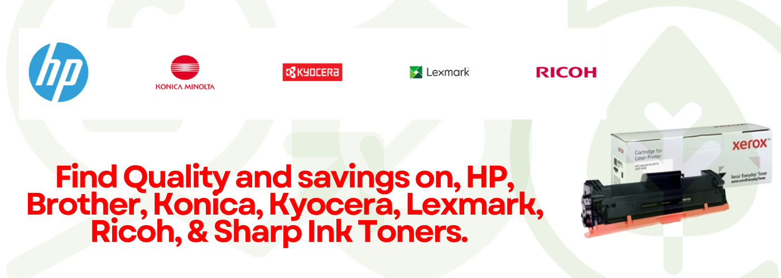
Order Today and Save!
[Click Here to Buy Now] or contact us to learn more about how these high-quality, cost-saving cartridges can benefit your business.
Best regards,
The (Customer Name) Team

